Lipid membrane characterization
This document describes how Lipid membrane composition was determined for input in CHARMM-GUI in MD simulations.
We started with a excel filed extracted (‘B vitrea lipid composition’. Xlsx), containing lipid composition from another ctenophore: B vitrea, determined by Winkoff et al [10]. Here, the steps applied are:
- We first go with sample 1, and we sum each of the values in the columns which contain the different kinds of the lipid family. For example, 30:0 means that the lipid tail has 30 carbons and 0 double bounds
- Now we do the same for the rest of the rows (samples). We will have 8 sums. So now we average them (sum all of them and divide by 8). This results in the following
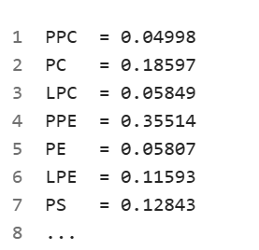
- This table represents the averaged class fractions. It sums 1.05. This means that we need to normalize them
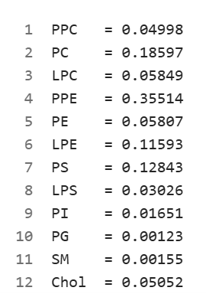= 1.05 as sum

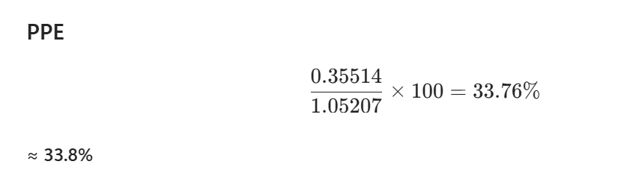
- And now, we need to take these normalized percentages to values that CHARMM GUI understand, with the issue that these exact molecules don’t exist in CHARMM GUI, but we can choose molecules that resemble them. Now the reasoning to assign values to each peptide class:
- PPE (33.8) POPEE (25) (Ether/Plasmalogen) and DOPE (15) (PE)
- PPC (4.7) POPCEE (Ether plasmalogen) (raised to 10 so as to still represent Plasmalogen)
- PC (17.7) = POPC (20)
- PS (12.2) = POPS (12)
- PI (1.6)= PI (3)
- Cholesterol (4.8) = Sterols (10) because cholesterol is emphasized and is commonly attachable to GPCR
- LPE (11) = PLPE (5) Can destabilize lipid bilayers
We obtain this table:
Category in CHARMM-GUI | Lipid | Upper | Lower
Ether/Plasmalogen Lipids | POPEE | 25 | 25
PE Lipids | DOPE | 15 | 15
Ether/Plasmalogen Lipids | POPCEE | 10 | 10
PC Lipids | POPC | 20 | 20
PS Lipids | POPS | 12 | 12
PI Lipids | POPI | 3 | 3
Sterols | Cholesterol | 10 | 10
PE Lipids | PLPE | 5 | 5
This is the same table reflected as Table 2 in the report, and is used as input for M. leidyi MD simulations.

